1/30/2021 Created by Min

**To push GitHub and Heroku.**

Create a dedicated repo for Heroku deployment. Outside of the repo root folder, let us create a new folder:

~/heroku-deployment

**For example, this is my repo root folder** 

**Let us create heroku-deployment folder here.**



Copy all files from module03a to ~/heroku-deployment

Then at cd to ~/heroku-deployment

How to know the configuration is correct? Try this command and see the result.

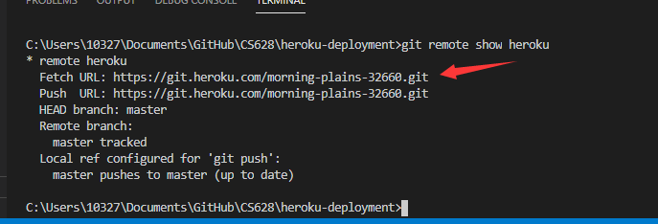

That is successful example. Make sure you copy the .git folder from original Module03a.

Then you can do

$git add .

$git commit -m “Module <number>”

$git push heroku master

**If you are successful to push to Heroku, make sure to delete the .git folder which is in the module03a folder so that you are able to push the content of module03a to GitHub.**

If you have already pushed embed repo to your GitHub, you can follow these steps to get rid of the non-content folder module03a.

**$git rm –cached module03a**

**$git commit -m “delete module03a”**

**$git push origin master**

Then, you can double-check your remote branch on GitHub, the module03a folder should be gone.

Then again, do the git command again like.

**$git add .**

**$git commit -m “Module<number”**

**$git push origin master**

If you still have any questions, feel free to reach out TA to help you.